Spring MVC

Model View Controller

Client → Request → Dispatcher Servlet ( Front Controller) →Controller→View Resolver→ View → Response

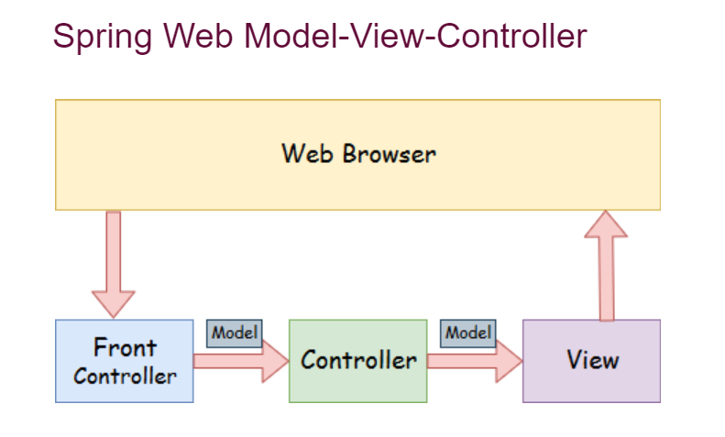

[11:06 AM] Preeti Yadav

<https://mvnrepository.com/artifact/org.springframework/spring-webmvc>

[11:06 AM] Preeti Yadav

<https://mvnrepository.com/artifact/javax.servlet/javax.servlet-api>

Maven Repository: javax.servlet » javax.servlet-api

Steps to create Spring mvc app

1. Load the spring jar files or add dependencies in the case of Maven
2. Create a folder inside "main" for java class/Controller
3. Create a folder under WEB-INF for jsp files

1. Create the controller class under java class folder
2. Provide the entry of controller (i.e. dispatcher servlet) in the web.xml file
3. Create a spring-servlet.xml under WEB-INF folder and Define the bean in the this XML file (spring-servlet.xml)
4. Display the message in the JSP page
5. Start the server and deploy the project